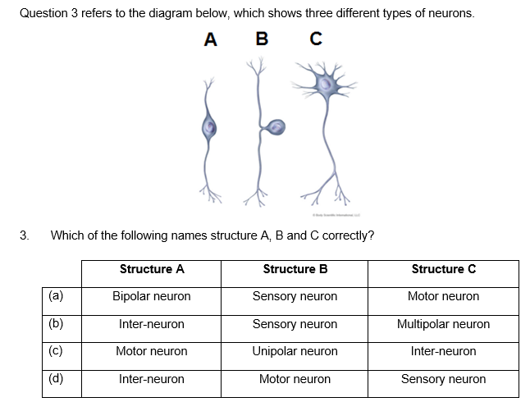

Below is a diagram of a neuron.

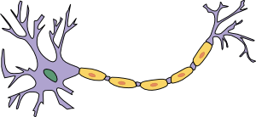

**B**

**C**

**A**

1. Name the structure A and describe its role (2)

*Dendrite – receives nerve impulses and carries them towards cell body*

1. What is the name and function of the cells labelled B (2)

*Schwann Cell – forms the myelin sheath*

1. What is the neurilemma and what is its function? (2)

*Outermost layer of the myelin sheath, functions to protect the sheath and guide repair if the neuron is injured.*



Below is a diagram of a neuron.



**B**

**C**

**A**

1. Name the structure A and describe its role (2)

*Dendrite – receives nerve impulses and carries them towards cell body*

1. What is the name and function of the cells labelled B (2)

*Schwann Cell – forms the myelin sheath*

1. What is the neurilemma and what is its function? (2)

*Outermost layer of the myelin sheath, functions to protect the sheath and guide repair if the neuron is injured.*